◆ Platform User Guide — Peer Teacher ◆
For: the teacher assigned to visit a colleague's unified lesson
Your visit is neither an inspection nor a grade: you read your colleague's plan, attend the lesson, and leave with one action you take for yourself. Your sidebar is four steps in the order of your visit.
Before you start — four things that concern everyone
1. Open the link — https://ahseyam.github.io/unified-lesson/
2. Switch to English — the EN button, top right
3. Choose your role — one card per role
4. Enter your staff number — you are identified by it, not by your name

• Open the link: It runs on phone, laptop and tablet with nothing to install. Bookmark it — it is your single reference; do not rely on a copy someone sends you, or you will be working from yesterday's data.
• Switch to English: Press it once and the choice is remembered on your device. Arabic is the default for everyone, so nothing changes for your Arabic-speaking colleagues. You may enter your own text in English or Arabic — both are kept as typed.
• Choose your role: Each role sees only what concerns it: its own buttons, screens and reports. You will not see what is not yours, and you cannot press a button that destroys someone else's work.
• Enter your staff number: Names repeat and are spelled in different ways, so the same person appears twice in the reports. If your number is on the roster, your name and subject are filled in for you.
❖ Step by step — with pictures every screenshot is taken from the platform itself, not drawn or imagined
1 Sign in with your role
• Choose the “Peer teacher” card and enter your staff number.
• Do not choose the “Teaching teacher” card — each role has its own screens.
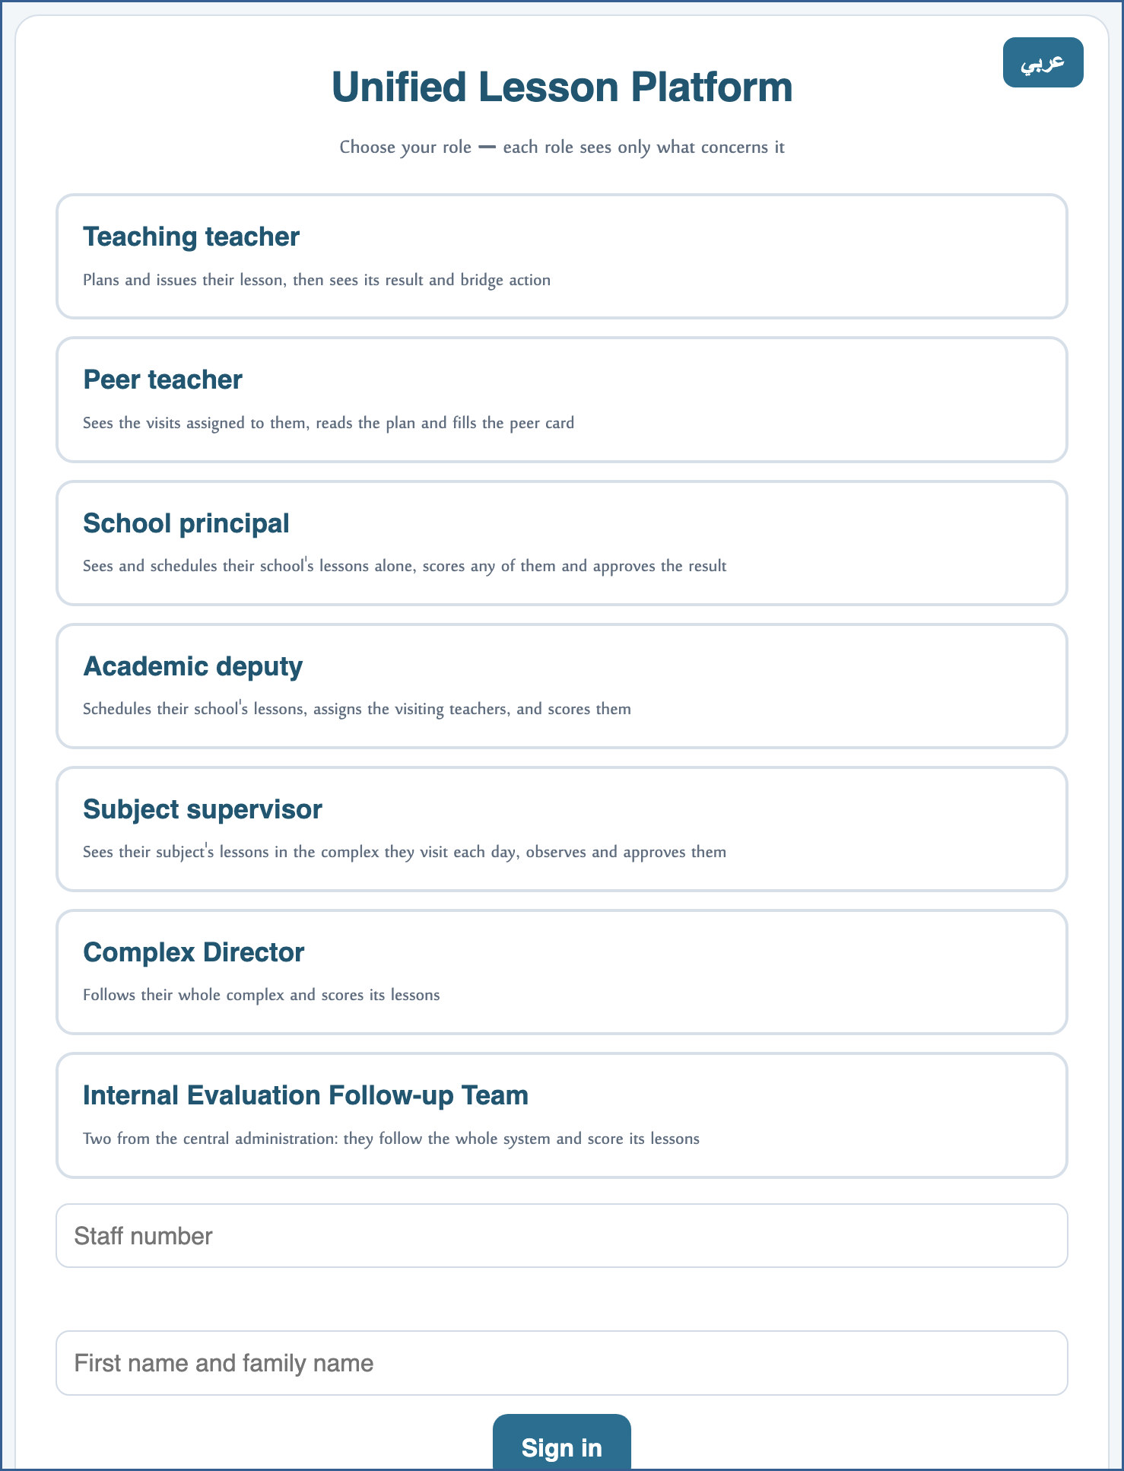
A live screenshot of the platform itself
2 Start from “My assigned visits”
• The first thing you open: what has been assigned to you, with its time, its school, your colleague's name and the state of their plan.
• A counter in the sidebar tells you how many visits await your card.
⛔ No visit appears until the school's academic deputy assigns it — ask them if it is late.

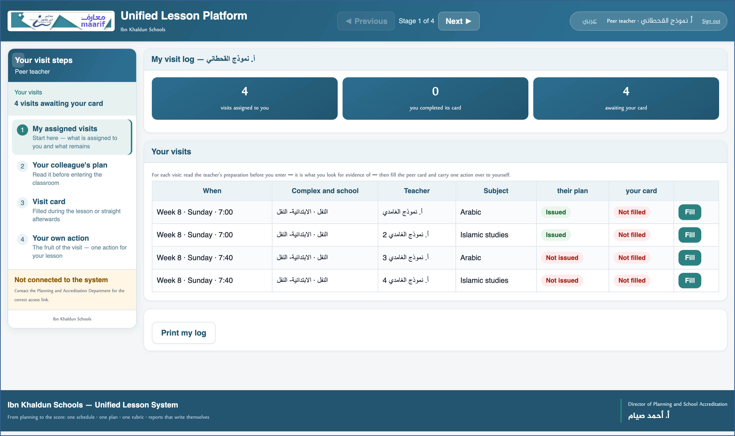
A live screenshot of the platform itself
3 Read your colleague's plan before you go in
• The second stage is “Your colleague's plan”: a sheet with what will be delivered in the lesson.
• The time map, its stages and the strategy card — read before entering.
• Print it or open it on your phone so it is at hand during the lesson.
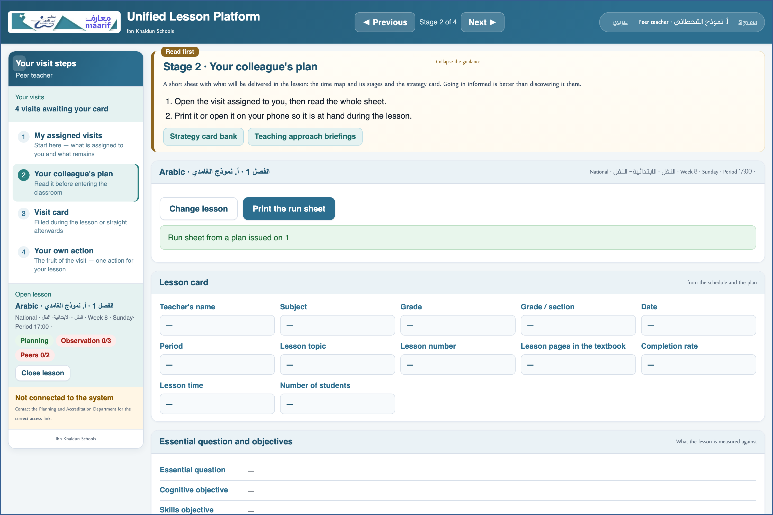
A live screenshot of the platform itself
4 Fill the visit card
• The third stage is “Visit card”, and it is short: what happened, what helped you, and what you will apply.
• Fill it during the lesson or straight afterwards — most of what is written days later is lost.
• No observer rubric falls to you and no indicators are rated — that is not your part.
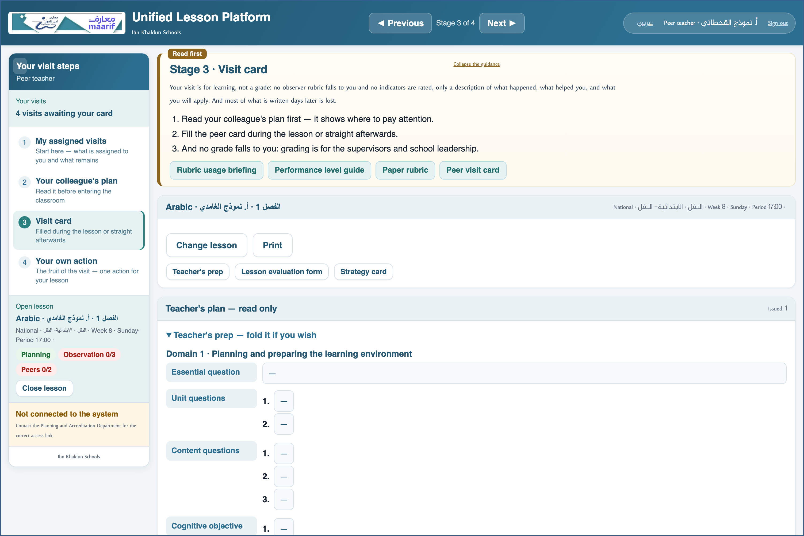
A live screenshot of the platform itself
5 Carry your action
• The last stage is “Your own action”: a commitment to yourself, not a judgement on your colleague.
• One specific action that can be seen in your next lesson — that is what is followed up with you.
• The lesson result appears if the observers recorded it — to read, not to edit.
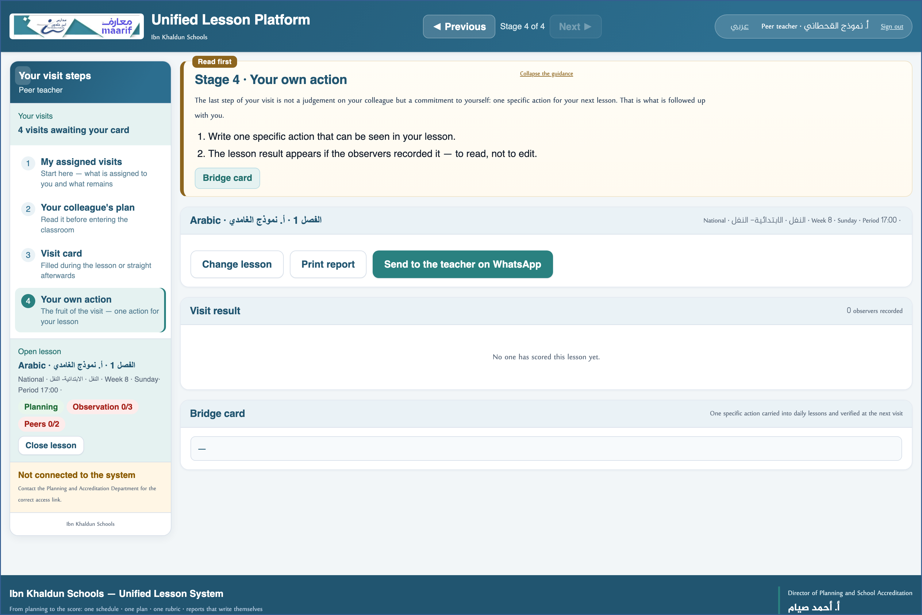
A live screenshot of the platform itself
❖ Where things usually go wrong before you ask — the most common cases
What happens | Why, and what to do
No visits are assigned to me | Assignment is by the academic deputy, using staff numbers. Check you signed in with your own number.
I cannot find the entry grid | Because you do not schedule anything. Your sidebar is four steps only, and that is deliberate.

❖ Frequently asked
Q: How many visits do I owe?
A: Two per term — the counter in the sidebar says what is left.
Q: Do I give my colleague a grade?
A: No. Grading is for the observers; your card is description and benefit.
Who to contact
If what concerns you does not appear, or something that is not yours does — contact the Planning and School Accreditation Department.
If the page does not open at all — check the link above and your connection.

https://ahseyam.github.io/unified-lesson/
Planning and School Accreditation Department · Ahmed Seyam

